Safe Food/Grocery Delivery During COVID-19 Pandemic

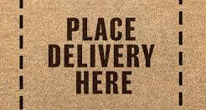 | No-Touch Delivery  - Ask delivery person to drop off food at door  - Ask Delivery person to knock/call on arrival and step back 2 meters
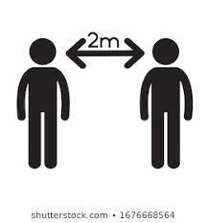 | No-Touch Payment  - With credit card over phone or internet  - With cash practicing social distancing (stay 2 meters apart)
Wash Hands
- After you bring in the delivery/change
- After putting groceries away
- After cleaning surfaces
Clean Surfaces
- Counters
- door knob
- door bell etc.

