Protecting Elders from COVID-19

While most COVID-19 infections cause only mild illness, our Elders, especially those with pre-existing conditions like diabetes, heart disease, and lung disease, may be at higher risk from the new virus.

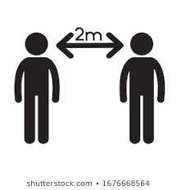 | Social Distancing  - Avoid in person visits
Grocery Shopping
- Shop for your Elder
- Arrange “no-touch” delivery
Virtual Connection
- Call often
- Try video calling
- Get the grandchildren to make videos for grandparents

